Kunal Mukherjee

2/15/19

Dr. Marc Mitchell

Project 1

Project Schematic

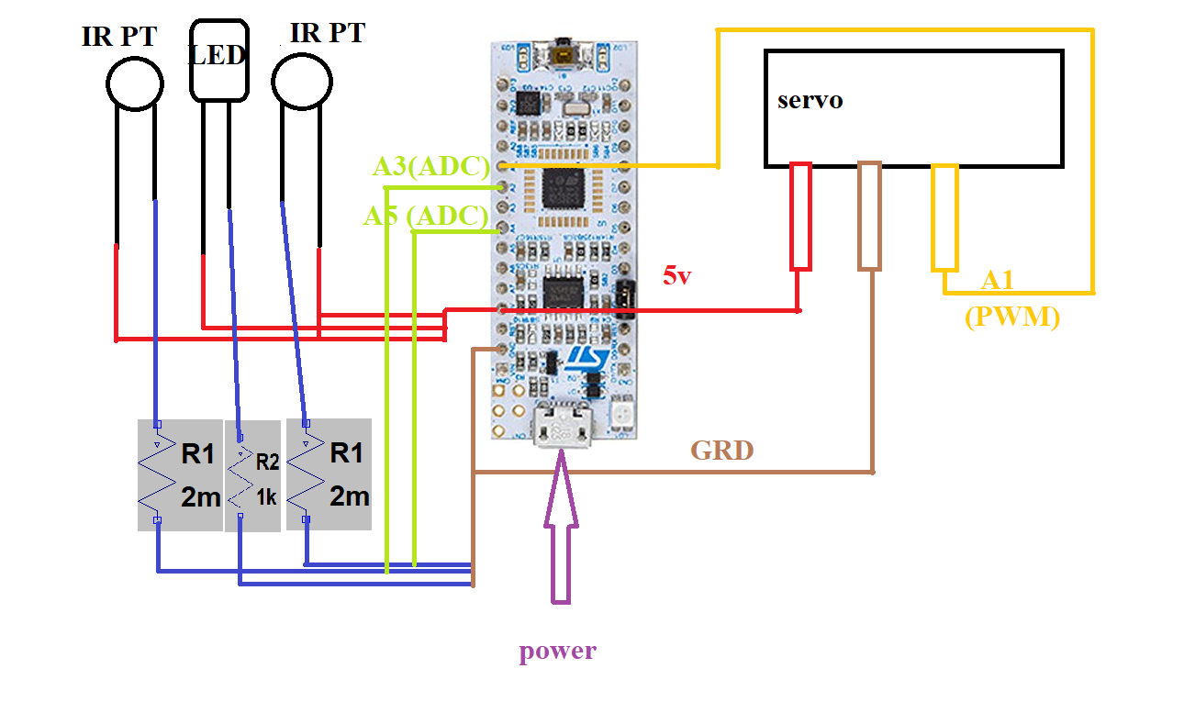

The physical design and the software coding were not the most difficult part of the project. The most difficult part of the project was signal conditioning. The software part has some minor issues as I believe using sequencing the adc channel and using interrupt would be a better design choice as well as optimize the code. I manually had to turn the adc off and on, everything. I think that wastes processor clock cycle and dissipates more energy than necessary. In hindsight, I spent a lot of time looking at the wrong port a I was going by what was in the physical body of the board rather than looking at the pin out in the documentation. So, my sequencing code might have worked but since my adc was connected to the physical wrong channel, the pin was not reading any input.

The signal conditioning was extremely empirical and constitutes majority of the design choices. For example, to get my tracking to work, I had to pass over 150 mA current through the LED, for the IR to reflect back with such intensity that is being detected by the IR transistors. I also connected the IR transistor directly to +5V and the current limiting resister was connected to the ground. In the way, when the IR transistor detects no IR, it shows around ~600, but once it detects the IR then the adc value goes up because now there would be a potential difference as current will pass through IR transistor. I also had to use 2 MΩ resistor to make the device extremely sensitive so that it can detect deflected IR. I started with 500 Ω and with a bad decision, and slowly I increased the resistor values and choosing 2 M Ω was a desperation choice, and it worked as the previous values were showing me ~.50V difference when it was detecting deflected IR. But, 2 MΩ has almost ~2.1 V increase when it detects deflected IR.

The project could have been more accurate, and tracking could have been better, if I had access to more powerful IR emitter or use many LED together so that the IR reflected would be strong enough for the transistor to detect. It could also be better if I had access to a 2 MΩ potentiometer, so that I could test and figure out which resistor value for the IR transistor works best. The device steps to move also took a long time, so the steps for each move should be dynamically changed depending on the object it is tracking. Also, the IR sensor were customized for a specific backlight, and it will have hard time tracking something in a different lighting condition. An algorithm, that looks at the background gradient and dynamically changes the background number which predicts the IR reflected number threshold. Ultimately, to make this project really well, all the #define number needed to be a volatile define, so that during run-time we can change the values dynamically so that this device can be optimized for any condition.